**Opening a Peruvian – Nikkei Restaurant in Toronto, CA**

**I. Introduction**

**A) Description of the Business Problem & Discussion of the Background**

**Problem:** *Opening a Peruvian-Nikkei Restaurant in Toronto, Canada*.

Toronto, the capital of the province of Ontario in Canada is considered one of the most diverse cities in the world with almost half of its residents being foreign born and half of its population being a visible minority. Since the area of Toronto has the largest Latin American community in Canada, we need to determine if it’s a profitable idea to open a Peruvian-Nikkei Restaurant in one of its neighborhoods.

We will analyze several boroughs/neighborhoods in Toronto with significant Latin American population in order to determine the most lucrative area to open a Peruvian-Nikkei restaurant by extracting their demographic data as well as Peruvian restaurants located in these neighborhoods.

**B) Target Audience**:

1) Investors or Restaurateurs who would like to invest or open a Peruvian-Nikkei restaurant in Toronto, Canada.

2) Latino population that enjoys Peruvian-Nikkei cuisine.

**II. Data Description**

**A) I considered the data from different sources:**

1) I will use Wikipedia in order to gather information about the neighborhoods in Toronto, CA such as their names, postal code and boroughs; therefore, we will use the “List of Postal Code of Canada: M”: <https://en.wikipedia.org/wiki/List_of_postal_codes_of_Canada:_M>

2) I will use Geospatial Data to obtain the geographical coordinates of the neighborhoods in Toronto.

3) I will use Wikipedia to obtain Toronto’s Neighborhoods’ Demographics and to find out the highly populated Latino neighborhoods. <https://en.wikipedia.org/wiki/Demographics_of_Toronto>

4) I will use Foursquare’s explore API in order to obtain information about the various Peruvians restaurants located in the densely populated Latin American neighborhoods.

**B) Methodology – Data Cleaning**

1. I scraped the data from the Wikipedia page “List of Postal code of Canada : M” and I cleaned it to obtain a dataframe with information pertaining to the Postcodes, Boroughs and Neighborhoods.

1. I added geographical coordinates to the neighborhoods by extracting data from the Geospatial CSV file.

1. I used the PostCodes to merge both dataframes and created a new dataframe containing the following columns: Postcode, Borough, Neighbourhood, Latitude and Longitude.

1. I scraped the Demographics of Toronto’s Neighborhoods’ Wikipedia Page in order to find out the neighborhoods with a high Latino population. There were only 4 neighborhoods: Davenport, York Centre, Humber River-Black Creek and York South-Weston.



1. I utilized Foursquare’s API to find out how many Peruvian Restaurants were located in the Toronto Neighborhoods, and I was only able to find 4 Peruvian Restaurants in the Toronto area.

**III. Data Analysis**

1. I used folium library to visualize the Peruvian restaurants’ locations in each borough of Toronto.

1. Then, I try to find out the relationship between Latin American neighborhoods and Peruvian Restaurants.

I try to visualize the relationship by using bar charts:

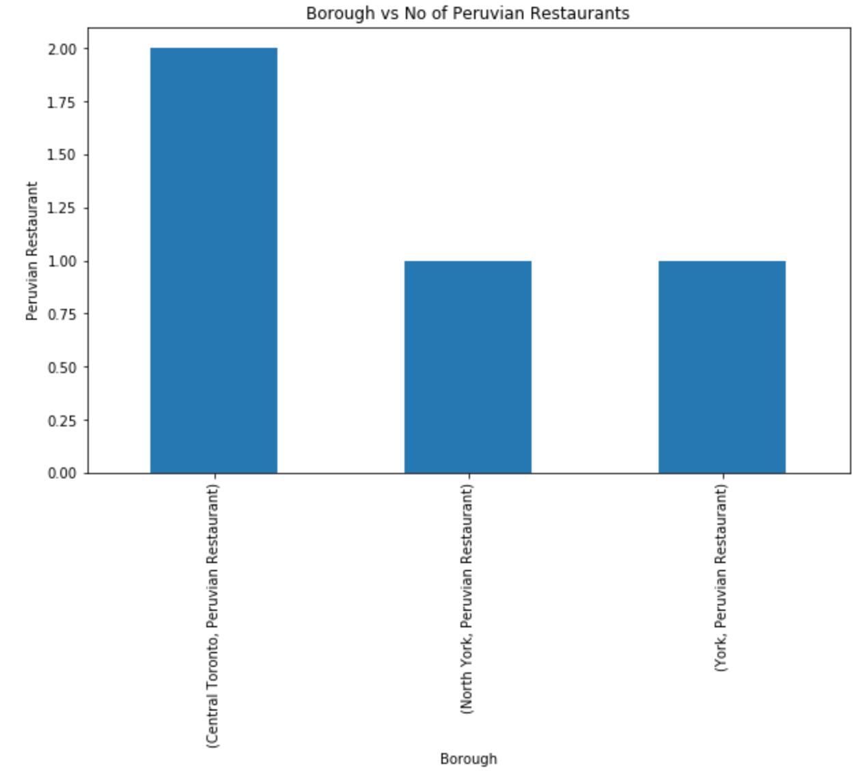

1. Analyze the relationship between neighborhoods and Latino Population. I extracted the neighborhoods with the highest number of Latin American population and created a new dataframe. A screenshot of a cell phone

   Description automatically generated

1. Since there were only a few Peruvian Restaurants in the Latino Neighborhoods, I decided to use Foursquare to see the types of Restaurants around the Toronto area. Then, I merged the Foursquare dataframe with the neighborhood dataframe to see the restaurants’ neighborhoods’ location.

**Predictive Modeling:**

We have different restaurants in the Toronto area neighborhood; therefore, I used the unsupervised learning K-means algorithm to cluster the neighborhoods.

**Clustering the Toronto Neighborhoods Using K-Means with K = 5**

**Folium Map for the clusters of the restaurants’ neighborhoods**

I analyze each cluster to determine the type of restaurant (cuisine) located in each neighborhood:

Cluster1:

Cluster2:

Cluster3:

Cluster4:

Cluster5:

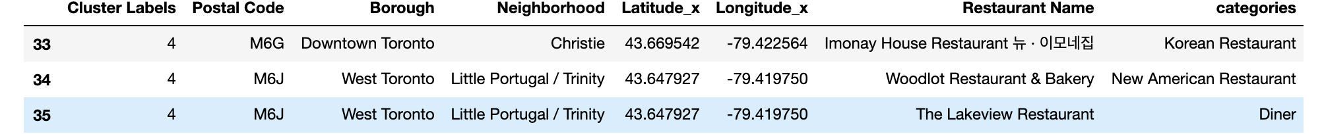

**Results:**

I started analyzing the Latino neighborhoods and the number of Peruvian restaurants located in those neighborhoods by extracting the demographic data of Toronto and by using Foursquare. However, I was only able to find a few Peruvian restaurants located in the densely Latino populated neighborhoods. Therefore, I decided to look at the type of restaurants located in the Toronto area and found multiple cuisines. When I used k-means and clustered the neighborhoods, I realized the best location to open a Peruvian restaurant is in Downtown Toronto. This area seems to have a variety of restaurants ranging from American to Indian to Chinese cuisine, etc.

**Discussion:**

We still need to look further to determine the best neighborhood within the downtown Toronto area since we will be competing with multiple cuisines. Also, another factor we need to determine is how well known is the Peruvian gastronomy in Canada. Even though Lima, the capital of Peru, is considered one of the top culinary adventure destinations, we need to find out if Canadians are adventurous enough to try something delicious and exotic.